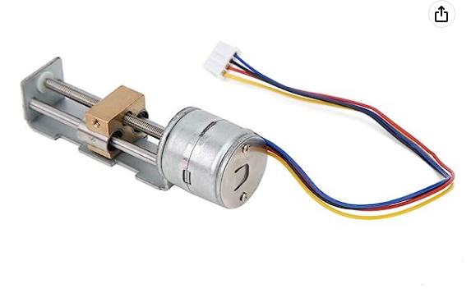

Mini Linear Stage Actuator, Small Slide Guide Rail Screw Lead Stepper Motor, Stepper Motor with Planetary Gearbox Reducer for Measuring Equipment, Printers

Feature:  
1. Can be used in DIY small sliders, projects, measuring equipment, printers.  
2. This product is miniature 2phase 4wire stepper motor with planetary gearbox reducer.  
3. Planetary gearbox reducer adopts all metal structure, strong and durable, has a long service life.  
4. Drive accurate diagonal lines to move the metal slider up and down, and the bracket is basically made of metal structure.  
5. The driving voltage of the motor is 5‑9V/200‑600mA, the higher the voltage, the greater the force and the greater the heat.  
  
Spec:  
  
Item Type: Stepper Motor  
Motor Type: 2-phase 4-wire system  
Drive Voltage: 5-9V/200-600mA (the higher the voltage, the greater the force, the greater the heat)  
Screw Length: Approx. 45mm / 1.8in  
Slider Stroke: Approx. 34mm / 1.3in  
Motor Diameter: Approx. 20mm / 0.8in  
Screw Diameter: Approx. 3mm / 0.1in  
Screw Pitch: Approx. 0.5mm / 0.02in (moving 0.025mm in one step, subdivision drive can be used if smaller)  
Step Angle: 18°  
Phase Resistance: 21Ω  
Blue A+Black B+Red B-Yellow A-